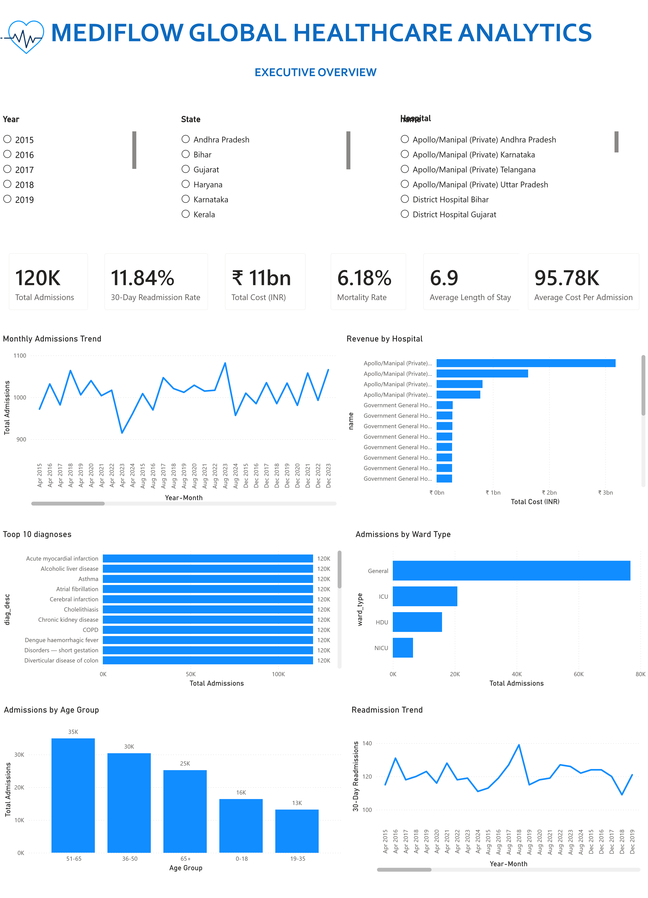

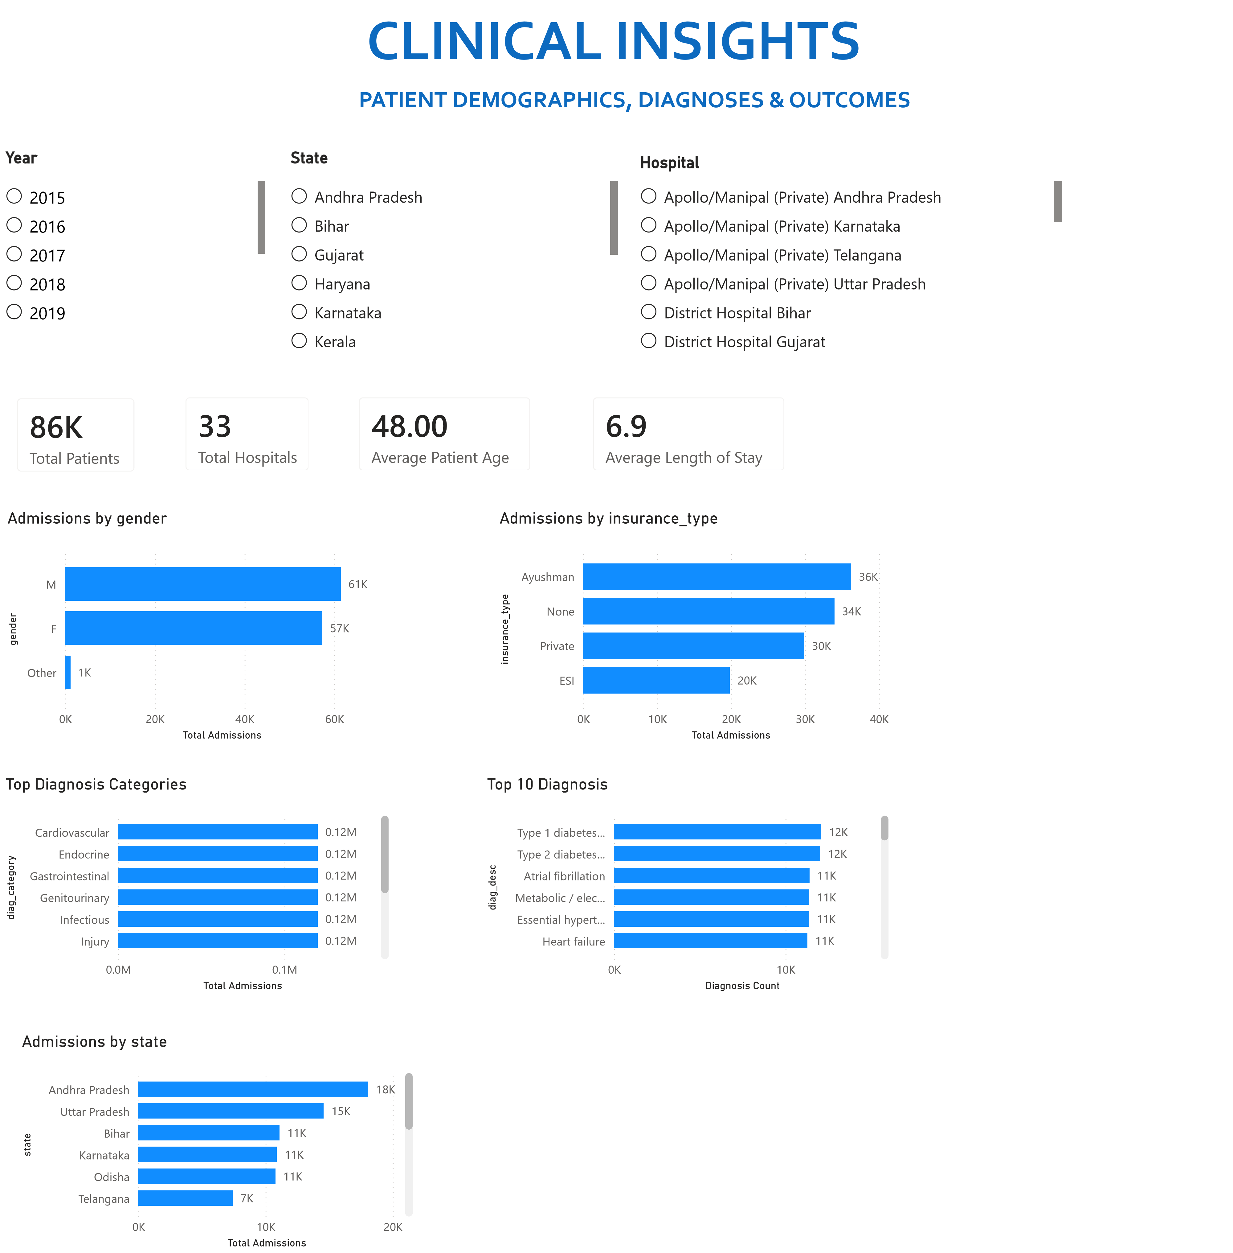

Power BI Desktop
FINANCIAL & OPERATIONAL INSIGHTS
REVENUE, COST & HOSPITAL PERFORMANCE
nameHospital
Year State
 Apollo/Manipal (Private) Andhra Pradesh
 2015 Andhra Pradesh
 Apollo/Manipal (Private) Karnataka
 2016 Bihar
 Apollo/Manipal (Private) Telangana
 2017 Gujarat
 Apollo/Manipal (Private) Uttar Pradesh
 2018  Haryana
 District Hospital Bihar
 2019  Karnataka
 District Hospital Gujarat  Kerala
Top 10 Hospitals by Revenue Monthly Revenue Trend
Total Cost (INR)
₹ 11bn
Average Cost Per Admission
95.78
K
Total Government Subsidy
6
bn
Total Out-of-Pocket
6
bn
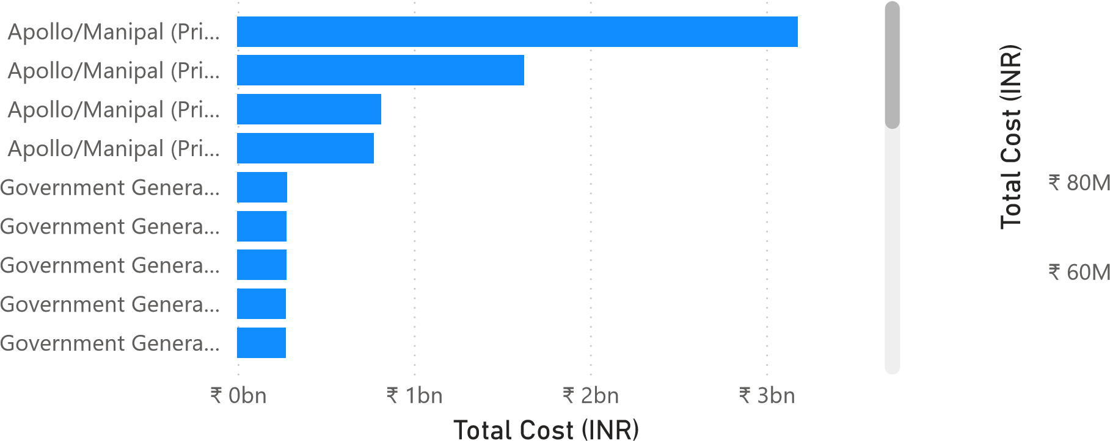
₹ 120M
name
Year-Month
Apr 2016
Aug 2021
Dec 2017
Jul 2023
Mar 2016
Aug 2022
Nov 2021
Nov 2017
Aug 2017
Mar 2020
Mar 2018
Aug 2019
Jun 2022
Jul 2018
Jun 2020
Oct 2016
Jul 2017
Jan 2018
Mar 2021
Jun 2017
Sep 2022
₹ 100M
Cost Category Distribution Revenue by Cost Category
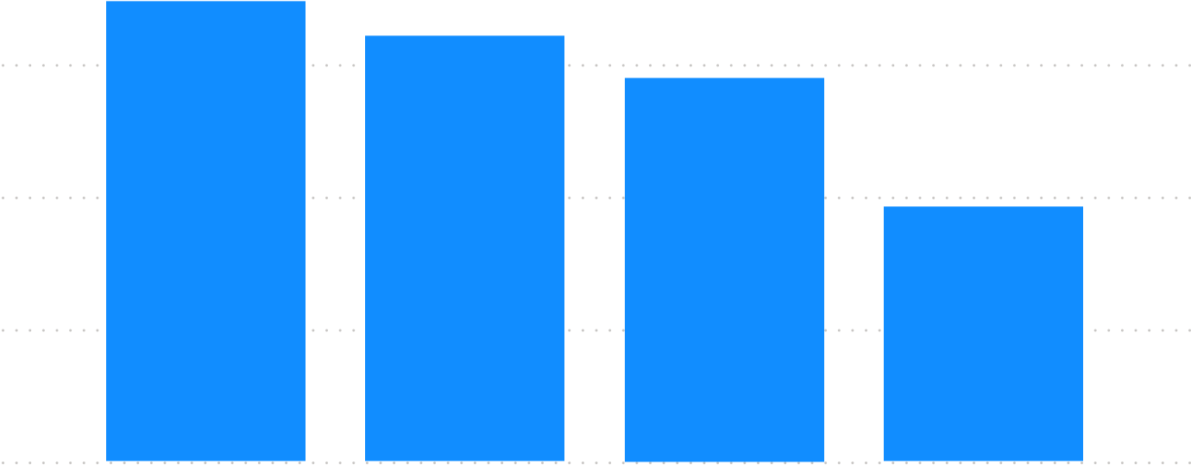
₹ 2bn (16.7%) ₹ 3bn (30.19%) ₹ 3bn
₹ 3bn (27.93%)
T
otal Cost (INR)
cost_category_{₹ 2bn}
Pharmacy
Procedure
₹ 1bn
Room
Lab
₹ 0bn
^{₹ 3bn}Pharmacy Procedure Room Lab ^{(25.18%)}cost_category
Revenue by State Average Cost by Hospital
Andhra PradeshApollo/Manipal (Pri…
name
state
KarnatakaApollo/Manipal (Pri…
Uttar PradeshApollo/Manipal (Pri…
TelanganaApollo/Manipal (Pri…
BiharGovernment Gener…
OdishaGovernment Gener…
KeralaGovernment Gener…
GujaratGovernment Gener…
₹ 0bn ₹ 1bn ₹ 2bn ₹ 3bn 0.0M 0.1M 0.2M
Total Cost (INR) Average Cost Per Admission

